SEAC (Retired) John Wayne Troxell Biography
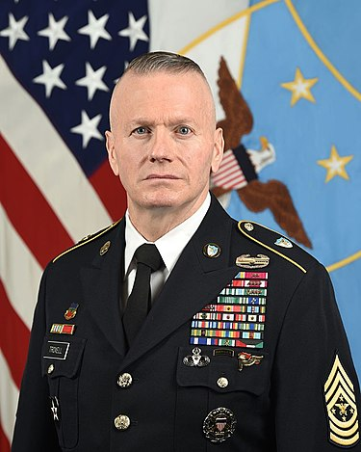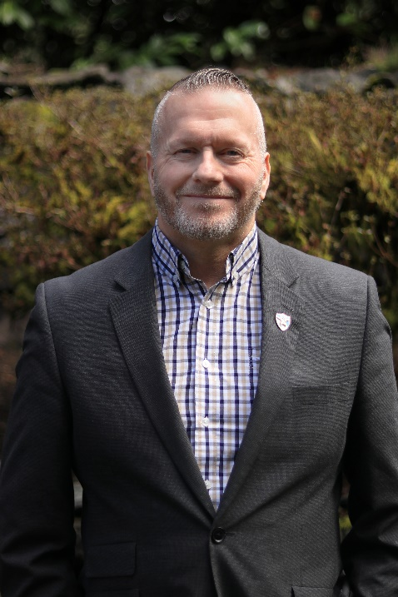
John Wayne Troxell is a retired United States Army senior noncommissioned officer who served as the third Senior Enlisted Advisor to the Chairman of the Joint Chiefs of Staff. In this capacity he served as the principal advisor to the Chairman and the Secretary of Defense on all matters related to the troops of the United States Armed Forces to include the lethality, readiness, fitness, welfare and deployability of the force, as well as joint force development and education. This position made Troxell the most senior enlisted member of the United States Armed Forces. He enlisted in September 1982 as an armored reconnaissance specialist and graduated from One Station Unit Training at Fort Knox, Kentucky.
Troxell served in the United States Army for well over 37 years in numerous units throughout his career. They include the 3rd Armored Cavalry Regiment in Fort Bliss, Texas; two tours in Germany with the 3rd Armored Division and 3rd Infantry Division; two tours in the 82nd Airborne Division in Fort Bragg, North Carolina; Campbell University Reserve Officer Training Corps in Buies Creek, North Carolina; and the Special Operations Division of Joint Task Force Six (Counterdrug) in El Paso, Texas. Troxell has served as the Command Sergeant Major of the 3rd Squadron, 17th Cavalry Regiment, 10th Mountain Division in Fort Drum, New York and Iraq; the Regimental Command Sergeant Major of the 2nd Stryker Cavalry Regiment in both Fort Polk, Louisiana and Fort Lewis, Washington; the Command Sergeant Major of the 4th Stryker Brigade Combat Team, 2nd Infantry Division in Fort Lewis, Washington and during the Surge in Iraq; the 21st Command Sergeant Major of the US Army Armor Center and Fort Knox, Kentucky; the Command Sergeant Major of the US Army Accessions Command and Human Resource Center of Excellence in Fort Knox, Kentucky; the Command Sergeant Major of US Army I Corps at Joint Base Lewis-McCord, Washington; the Command Senior Enlisted Leader of the International Security Assistance Force Joint Command in Afghanistan and the Command Senior Enlisted Leader of the United Nations Command/Combined Forces Command/United States Forces Korea. Troxell was sworn in as the SEAC on December 11, 2015 and finished his tour of duty on December 13, 2019. His official retirement date was March 31, 2020.
Troxell’s five combat tours of duty include making the combat parachute jump and service in Operation Just Cause in Panama, Operation Desert Shield/Storm, two tours in Operation Iraqi Freedom, and Operation Enduring Freedom in Afghanistan. As the SEAC, Troxell routinely visited troops deployed to countries around the world to include Syria, Iraq, Afghanistan, Somalia, Yemen, Libya and numerous others to gain the pulse of the force for the Chairman and Secretary. His military education includes Ranger, Airborne, Jumpmaster, Pathfinder, PLDC, BNCOC, ANCOC, and the First Sergeants Course. He is a graduate of Class 51 of the US Army Sergeants Major Course and the Command Sergeants Major Course. Troxell is also a graduate of the National Defense University Keystone Joint Command Senior Enlisted Course, the US Army War College Strategic Leader Development Course, the US Army Intermediate Strategic Leader Defense Course at the University of North Carolina at Chapel Hill, and the US Army Advanced Strategic Leader Development Course at Southwest Airlines and Exxon Mobile headquarters. Troxell is also a fellow at the Daniel K. Inouye Asia Pacific Center for Strategic Studies in Honolulu, Hawaii. His civilian education includes a master’s degree in business administration with a concentration in strategic leadership from Trident University in California.
Troxell’s awards and decorations include the Combat Action Badge, the Ranger tab, the Master Parachutist Badge with combat jump star device, the Pathfinder Badge, the Driver Badge, the Joint Chiefs of Staff Identification Badge, the 82nd Airborne Division, 10th Mountain Division, 2nd Infantry Division, I Corps, and IJC Combat Service Identification Badges, the Defense Superior Service Medal with two oak leaf clusters, Legion of Merit with two oak leaf clusters, Bronze
Star with oak leaf cluster, Meritorious Service Medal with four oak leaf clusters, Joint Service Commendation Medal, Army Commendation Medal with “V” device and four oak leaf clusters, Army Achievement Medal with silver oak leaf, Joint Meritorious Unit award with oak leaf device, Meritorious Unit Commendation, Army Good Conduct Medal (12 awards), National Defense Service Medal with bronze service star, Armed Forces Expeditionary Medal with arrowhead device, Southwest Asia Service Medal with two campaign stars, Afghanistan Campaign Medal with one campaign star, Iraqi Campaign Medal with one campaign star, Global War on Terrorism Expeditionary Medal, Global War on Terrorism Service Medal, Korea Defense Service Medal, NCO Professional Development Ribbon with bronze award numeral 4, Army Service Ribbon, Army Overseas Service Ribbon with award numeral 4, NATO Meritorious Service Medal, NATO Medal (ISAF), Kuwaiti Liberation Medal (Saudi Arabia), and the Kuwaiti Liberation Medal (Kuwait). He is a Silver Medallion recipient of the Order of St. George (Armor Association), a Centurion of the Order of St. Maurice (National Infantry Association), and a recipient of the Honorable Order of Saint Barbara (US Field Artillery Association).
During his time as the SEAC, Troxell campaigned for a distinctive rank insignia for the SEAC position much like each of the Service Senior Enlisted Advisors and on December 8, 2019 the Chairman of the Joint Chiefs of Staff approved the new rank and title and pinned the new rank on Troxell at a ceremony in the Pentagon.
Troxell is married to the former Sandra Jimenez, his wife of over 37 years from El Paso, Texas. They have three adult sons and four grandchildren.
Since his military retirement, Troxell has opened his own consulting firm, PME Hard Consulting, LLC, and now serves as a strategic advisor and brand ambassador for the US Chamber of Commerce Hiring Our Heroes Foundation, as well as brand ambassador for Veterans Lending Group, BeaverFit USA, Muscle Mac, Zyn Drink Products, Skinny Pasta and Eyewear Safety Systems (ESS); he serves as the Vice President for Strategic Planning for DFND USA; executive consultant for 5th Principle, LLC; and he also serves as a military consultant for Alpha Warrior 360 gyms and also consulted for Film 45 movie production company. Troxell is a strategic advisor for FitOps Foundation and serves on the advisory boards for the Tactical Combat League, Allied Forces Foundation, Emory Healthcare Veterans Program, Warrior Suicide Prevention Foundation, Our Community Salutes Foundation and the Patriot Foundation. He continues to focus on supporting service members, veterans, and their families.
SEAC (Retired) Troxell and Sandra reside in Lakewood, Washington.

