BIOGRAPHY

SANDRA TROXELL
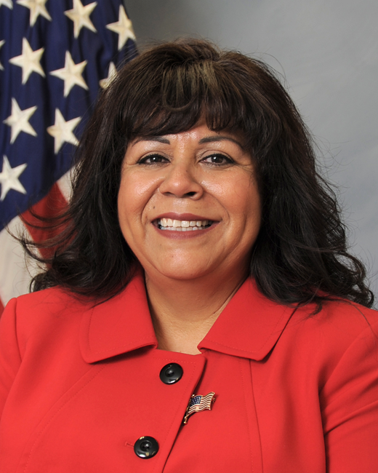

Sandra Troxell was born and raised in El Paso, TX and graduated from Bel Air High School in 1981. She married John Wayne Troxell of the United States Army in 1983 and has been a devoted Army spouse for 37 years. Sandra and John have three adult sons, Daniel, Michael and Bryan, and two daughters-in-law, Maria & Andrea, as well as one fiancé Emily. They also have four grandchildren, David, Melody, Claudio and Luna. All of their children and grandchildren reside in the state of Washington in the United States.
Throughout her dedicated life as a military spouse, she has distinguished herself by outstanding public service to military families in various capacities. Most recently, while her husband served as the Senior Enlisted Advisor to the Chairman of the Joint Chiefs of Staff (SEAC) in Washington, DC, she devoted much of her time volunteering for numerous agencies within the National Capital Region and in the community. These included the American Forces Spouses Club, the Capital Area Military Spouses Club, Senior Forum on Military Spouses Employment Partnership, and serving as an honorary board member and avid volunteer for the Second Hand Rose Thrift Shop. Additionally, she volunteered extensively with the Army Community Service and the USO. She also accompanied her husband on numerous troop visits to include multiple USO trips to Afghanistan (twice), Iraq (twice), Poland, Turkey, Qatar, The United Arab Emirates, Germany and aboard the USS Abraham Lincoln in the Persian Gulf. Additionally, she was a consistent guest speaker and mentor for the United States Army Sergeants Major Academy Spouses Program in Fort Bliss, TX. Prior to their tour in Washington, DC she was widely recognized for her outstanding achievements and dedications in Korea while John served as the Command Senior Enlisted Leader of the United Nations Command, Combined Forces Command and the United States Forces Korea. From October 2013 to December 2015, Sandra was extensively involved in various efforts including military spouses’ forums, spouse groups, the Good Neighbor Program, and service as a Family Action Plan mentor.
Sandra has been an integral part of the career of her husband and has been by his side from the rank of Private to his final assignment as the Senior Enlisted Advisor to the Chairman of the Joint Chiefs of Staff. Now that John has retired, Sandra serves as the co-founder and co-owner of PME Hard Consulting, LLC along with John. They reside in Lakewood, Washington near their children and grandchildren.

